# Pets

You need to add 20 things to this document. (Make sure to number them just as I did in the example.) It may be helpful to copy and paste this list and then fill it in as you go along. All image names must start with your location, e.g yellowstone_sunset.jpg unless you are using a link from the internet.

## Miumiu

1. 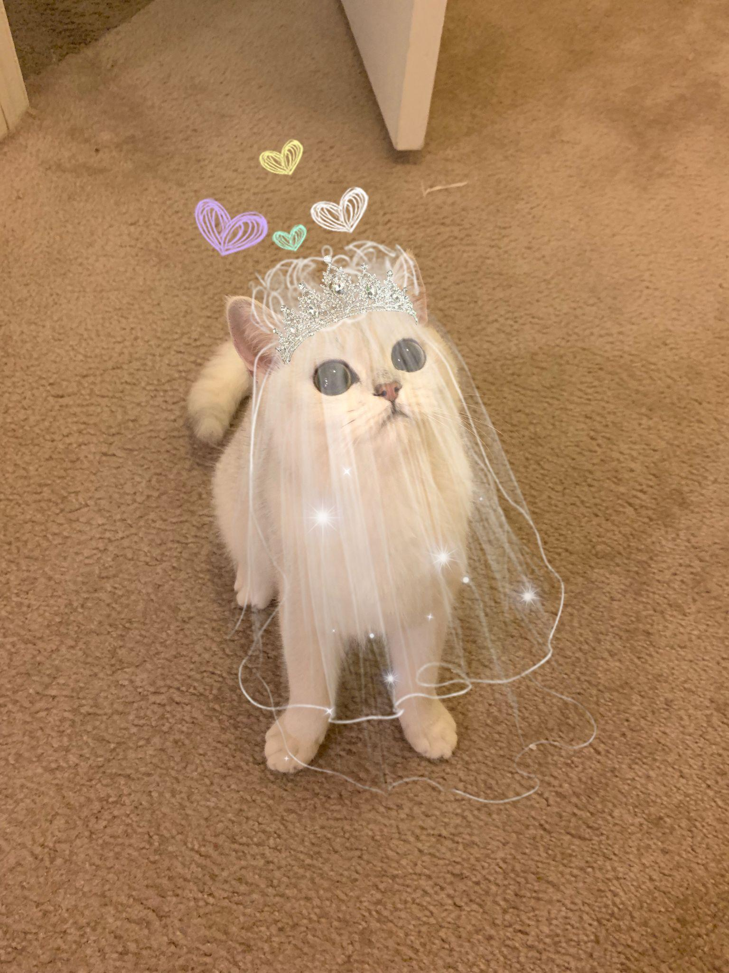
2. miumiu.jpg
3. Silver gradient British shorthair cat in a wedding dress
4. Miumiu is a five-year-old silver gradient British shorthair cat. She was born in Russia and raised in the United States and China. She is a mom of two babies. She loves to sleep.
5. Miumiu is kind of timid and afraid to meet strangers. But she is very close to her family, she loves to lie next to her family. She is very talkative and loves to meow.
6. **Photo Gallery**
7. miumiu_in_the_bag.jpeg
8. Silver gradient British shorthair cat in a pink bag
9. miumiu_on_the_bed.jpeg
10. Silver gradient British shorthair cat lying on the bed
11. miumiu_sleeping.jpeg
12. Silver gradient British shorthair cat sleeping on the bed
13. miumiu_under_sunshine.jpeg
14. Silver gradient British shorthair cat under the sunshine
15. **Likes**
16. Chicken breast
17. Sleeping
18. Observing birds outside the window
19. Mengyun Liu